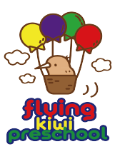
SMOKE-FREE POLICY

RATIONALE
Flying Kiwi Preschool have a completely smoke, alcohol and illegal substances - free environment, to promote healthy living and good habits for the kaiako and tamariki.

TE WHĀRIKI
Well-being/ Mana atua - Goal 1: Tamariki experience an environment where their health is promoted.

PROCEDURES
- Smoking, e-smoking and vaping is not permitted in early childhood centres or on centre grounds.
- A notice stating that smoking and vaping within the premises is forbidden, will be displayed at the entrance .
- All team members are required to smoke (including vaping) off the premises entirely and wash their hands and freshen their breath before attending to any tamaiti after smoking
- Any person entering the premises smoking will be required to extinguish the cigarette, pipe, etc. or they will be asked to leave.
- A copy of this policy is prominently displayed.
- Any complaints regarding this policy should be directed to the centre manager.
- This policy will comply with the Smoke - Free Environments Act, 1990 and will be reviewed annually.

LINKS TO:
- Smoke-free Environments Act 1990.

Date approved:
Review date:

